Greater Yellowstone Coordinating Committee
Gravel Pit Program
2009

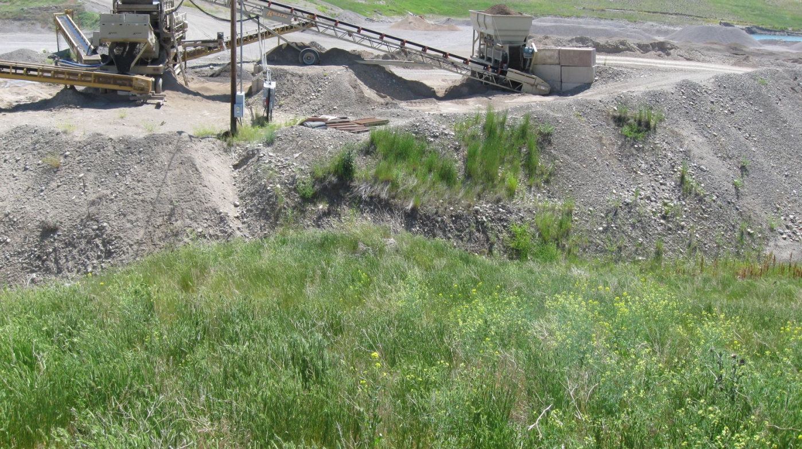

Final Report
Prepared by: Jody Fagan

Partners:
National Park Service Gallatin County Weed District
U.S. Forest Service Fremont County Weed District
U.S. Fish & Wildlife Service Carbon County Weed District
Madison County Weed District Park County Weed District
Park County Weed & Pest Control District (Wyoming)
Sweetgrass County Weed District
Teton County Weed & Pest Control District (Wyoming)
Table of Contents

Overview 3

2009 Pits Visited & Certification 4

Key to Weed Abbreviations 6

Overall Project Commentary 7

APPENDIX:
Pit Data Sheets & Certification of Inspection Forms

- Carbon County (MT)
- Fremont County (ID)
- Gallatin County (MT)
- Madison County (MT)
- Park County (MT)
- Park County (WY)
- Sweetgrass County (MT)
- Teton County (WY)

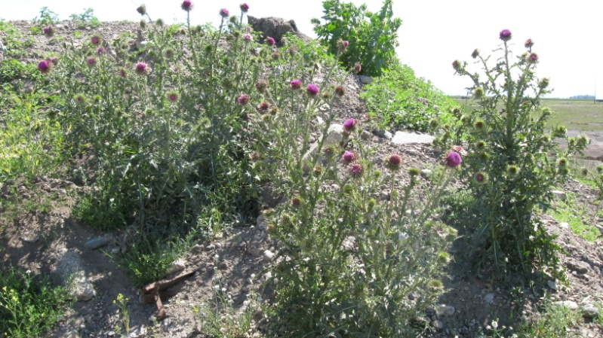
Overview

The Greater Yellowstone Coordinating Committee (GYCC) Best Management Practices sub-committee of the Noxious Weed Committee has identified sand and gravel pits as major contributors to weed spread within the Greater Yellowstone Area (GYA). Acting on this concern, the GYCC (with funding from the U.S. Forest Service), has hired a seasonal employee to inspect area gravel pits for the past two years with coordination and oversight from a National Park Service resource specialist(s). Seasonal employees were Patrick Lawrence in 2008 and Jody Fagan in 2009, both located and administratively supported by the Gallatin County Weed District in Bozeman. Ultimately, the program offers the opportunity to assess the level of noxious weed control in area gravel pits, educate operators on treatment, and in coordination with the National Park Service (NPS) provide a list of noxious weed-free certified sand and gravel pits to private, county, state and federal entities purchasing sand and gravel material. Over time, this effort will result in protecting native habitat and reducing future weed control costs.

Eight counties in the GYA were encouraged to assist with the program: Carbon (MT), Fremont (ID) Gallatin (MT), Madison (MT), Park (MT), Park (WY), Sweetgrass (MT) and Teton (WY). Overall, local weed coordinators, while swamped during weed season, were helpful with information on individual gravel pits and provided feedback on paperwork. Craig McClure (retired) and Eric Reintertson of the National Park Service also provided some support and direction. Local weed coordinators were invited to accompany the seasonal employee on the pit inspections but overall it was difficult to coordinate schedules. About one-third of pit operators participated directly in the inspections.

In 2009, I (Jody Fagan) was able to survey 38 pits in the GYA from 7/1/09 to 8/20/09 (using protocol developed by the GYCC Weed Committee) and I provided on-going assistance to several large pit operators wanting to bring their pits up to certification standards. Of the surveyed pits, I recommended 14, or 37 percent, to be certified. This percentage was up from 27 percent in 2008 but may be due to the fact that I had limited time and prioritized my work toward coordinating with pit operators who wanted to attain future certification. In addition, I did not survey many of the small county roadside sand and gravel storage areas, as was done in 2008.

Obviously, the other 63 percent of the pits have possible large noxious weed infestations and demonstrate the continued challenge that disturbed areas, such as gravel pits, pose to effective weed control. In addition, many of the county-run gravel pits (whether active or reclaimed) have large noxious weed infestations that are possibly difficult to address with limited budgets and staff.

In 2008, Patrick listed 191 sand and gravel pits in the GYA (active, inactive and reclaimed). In 2010, this number may need to be verified and the overall database updated (by obtaining the DEQ list). The list may be shorter due to pits not receiving final permitting and different economic conditions.

Overall in 2009:
- 38 pits surveyed
- 14 (37 percent) recommended for certification

GYCC Gravel Pit Inspection Program
2009 Pits Visited by Jody Fagan 7/1/09—8/20/09
(Knife River and TMC pits visited 2-3 or more times)

Certification Guidelines & Key

A: APPROVED: Exceeds requirements of GYA certification standards and contains only the specified gravel/borrow material with no non-native plants noted.

B: APPROVED: Meets requirements of GYA certification standards. Gravel/borrow material contains no tri-state (WY, MT, ID), regional or YNP listed weeds and only limited amounts of annual weeds and/or weeds not listed as prohibited or noxious.

C: APPROVED: Complies with minimum requirements of GYA certification standards. The gravel/borrow material contains variable amounts of prohibited or noxious weed species which were immature (no viable seed) when treated to prevent seed formation. These plant parts, although not usually desirable in gravel/borrow material, are not considered able to begin new infestations.

D: FAILED.

Gravel Pits Visited in 2009 with Certification Recommendations

Fremont County
- FR-65 State Pit: D
- Meadow Creek Pit: D
- Valley View: D
- Yale Creek: C

Gallatin County

- Alaska Pit (Knife River): D
- Belgrade Pit (Knife River): C
- Brownell Pit: D
- Cooper Gallatin: D
- Cosick Pit (TMC): D
- Ecton: D
- Haugland: D
- Huttinga: D
- Kamerman Pit (Van Dyken): D
- Kenyon Noble: D
- Morgan Pit (TMC): D
- Nuss Pit (TMC): B
- Storey Gravel (TMC): B
- Van Dyken Pit: D
- Zuelke: B

Madison County

- Bear Creek: D
- DSL Pit: B
- Ennis Dump/McKee: D
- JDL Construction: D
- Sphinx: D
- State Harrison: D
- Titan: D

Park County (MT)

- Brogan Sand & Gravel: B
- CIB: C
- Dan/Sue Nelson (Knife River): B
- Durgan Rock Pile: B
- STS Gravel (Fisher): B

Park County (WY)

- Black Rock Pit (Big Horn Ready Mix): C
- Cody North: D
- Red Pole: D
- Stampede: C

Teton County (WY)

- Evans Construction Main Pit: C
- Melody Ranch: D
- River Springs Pit (Evans Construction): D

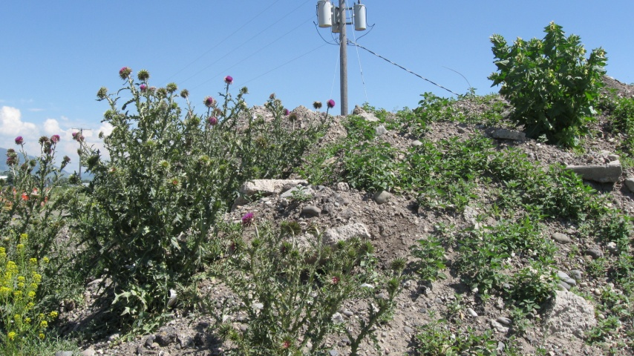

Key to Weed Abbreviations

Black Henbane Hyocyamus Niger HYNI
Bull Thistle Cirsium Vulgare CIVU
Canada thistle Cirsium Arvense CIAR
Field Bindweed Convulvus Arvensis COAR
Hoary Alyssum Berteroa Incana BEIN
Houndstongue Cynoglossum Officinale CYOF
Leafy Spurge Euphorbia Esula EUES
Common Mullein Verbascum Thapsus VETH
Musk Thistle Carduus Nutans CANU
Poison Hemlock Conium Maculatum COMA
Saltcedar Tamarix Ramosissima TARA
Scotch Thistle Onopordum Acanthium ONAC
Showy Milkweed Ascelepias Speciosa ASSP
Spotted Knapweed Centaurea Maculosa CEMA
Tall Buttercup Ranunculus Acris RAAC
Whitetop Cardaria Draba CADR
Yellow toadflax Linaria Vulgaris LIVU

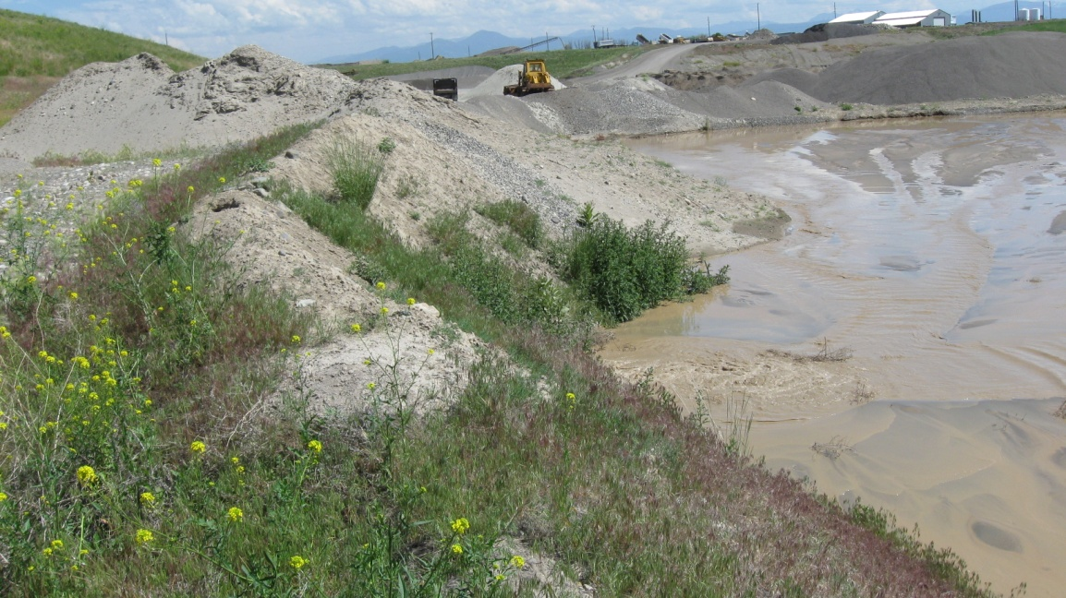

2009 Overall Project Commentary

The GYCC Gravel Pit Program is much-needed, even well beyond the counties bordering Yellowstone National Park. Sand and gravel are hauled up and down our roads by the thousands of tons annually. And this highly transferred material consistently harbors weed seeds and is often prime growing habitat for listed noxious weeds. Add this to the nature of gravel pits—they are highly disturbed areas without much native vegetation (if any) and with much traffic coming from a variety of locations, possibly on a daily basis—and you have a surefire recipe for large noxious weed infestations. After visiting pits in the GYA this summer and talking with a variety of pit operators, I’ve come to realize that gravel pits are one of the most challenging places for effective noxious weed control, and this program, along with continued direct assistance to pit operators, is needed more than ever.

In 2008, Patrick Lawrence did an excellent job of setting up a database of existing pits and their locations. I used his notebook into a tattered roadmap when I was on the road and visiting pits. While Patrick was able to visit 55 pits last year, I only made it to 38. Other unexpected time commitments for the Gallatin/Big Sky Noxious Weed Committee came up for me and I worked for the GYCC Gravel Pit Program only three-quarter time at best. (I was glad to have the job and the opportunity…thank you.) Also contributing to my visiting less pits was the fact that I focused on the larger pits mostly and didn’t worry as much about the small gravel storage areas that Patrick surveyed the previous year.

I also built relationships with the folks at TMC and Knife River. I visited several of their pits three times and provided ongoing assistance and feedback to them. This was time well spent, considering the large size of those pits and how much I see their trucks on our highways. Knife River, especially, made great progress on their Belgrade Pit this year. At the beginning of the season, Jackie Flikkema, Knife River environmental coordinator, believed the pit would never be certifiable, even though they were doing ongoing treatment. Once they found out certification could be attainable at some point, she and Dave Schmidt, general manager, really dug in and pushed weed control. The entire pit was treated 4-5 times this year and I was able to recommend certification at the minimum level. This wouldn’t have happened if they didn’t have the “certification carrot” at the end of the line. I’m confident they’ll continue this diligent work next year.

However, while pits like Knife River, TMC and the Black Rock Pit in Wyoming are wanting feedback and are working hard to deal with their weed infestations, Kenyon Noble and other large pit operators remain unconcerned and irresponsible. After an initial visit with Kenyon Noble in June with Craig McClure, John Ansley and others from the Gallatin County Weed District, Kenyon Noble blantantly rebuffed any further inspections or recommendations for weed control, citing high herbicide costs and time commitment. This is especially disheartening when one considers the large amount and variety of noxious weeds infesting this 80+-acre pit. Other pits remain in this category as well, including other Rick Ogle-owned pits in Gallatin County. In addition, many county pits I visited, including those in Fremont, Madison and Park (WY) counties, are harboring sizeable noxious weed populations that need to be addressed.

While it is currently in question whether this program will be continued next year, especially due to Craig McClure’s retirement and limited staff resources, some continued programmatic focus on noxious weed control in sand and gravel pits is much needed. If the program does continue, more support, feedback and involvement is needed from NPS personnel as well as the local weed districts. It may also be helpful for the GYCC to recommend yearly milestones for the program, and ensure there is support and a specified program structure for the seasonal employee to help ensure future success.

